|  |  |  |
| --- | --- | --- |
| Project Settings: <https://drive.google.com/open?id=1bIWSzxDlhNRyUOUX_9wq728ZlzKtD0T2mv1hEl6MYnA>  Please view project settings before start | | |

1. **Task Requirement / Description**
2. **Navigate to Task Area**
3. **UI Example**
4. **Programming Logic**
5. **Database**
6. **Changes to Commit ( developer to complete )**
   1. **Files / Folders to add to live site**
   2. **Database Changes to add to live site**
   3. **Developer notes / instructions for Project Manager**

**1. Task Requirement / Description**

After loading site into live site the customer is reporting some bugs.

I have updated the site setting spreadsheet to include ftp and phpmyadmin details for live site. I have also added ICE Coder to live site ( see settings doc for details )

Please investigate the following reported by customer:

1. Customer is reporting that when they login to admin site and add a image and description to a category using the “Edit Details” option in the action menu, the image is not showing in the public site. Please investigate and see if you can find problem.
2. Customer is reporting pdf links not working when uploading a pdf for a product, Please check, I may have already fix I copied pdf files from old site into upload folder of new site.
3. Some PDF has generated following error “The URI you submitted has disallowed characters” see if you can find, if not let me know.
4. Contact Us page email is not received and need to add a message to user “Thanks for your submission, one of our staff members will be in contact with you.” when a user submits the form.
5. Front page banner images are not auto scrolling
6. Remove “Cable Trays” page from products
7. Prices for product needs to be limited to two decimal places
8. When user submit form to get catalogue the email is not received by the user. and need to add a message to user “An email with a link to download our catalogue has been sent.” when a user submits the form.
9. Customer sent me a screenshot see below.

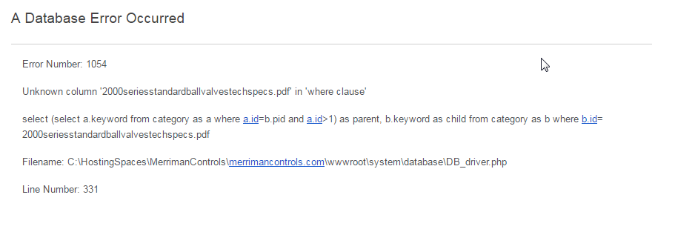

**2. Navigate to Task Area**

**3. UI Example**

**4. Programming Logic**

**5. Database**

**6. Changes to Commit ( Developer to Complete section 6a, 6b, 6c)**

This section is to help the Project Manager update the test site and live site. Please fill in the below area’s 6a, 6b and 6c, this is to inform the Project Manager as to what changes were made and needed to add update the live site

**6a. Files / Folders to add to live site**

Please add to the below table a list of files or folders that the Project Manager will need to upload to the live site.

|  |  |  |  |
| --- | --- | --- | --- |
| Folder Name: |  | | |
| File Name | File Name | File Name | File Name |
|  |  |  |  |
|  |  |  |  |
|  |  |  |  |

|  |  |  |  |
| --- | --- | --- | --- |
| Folder Name: |  | | |
| File Name | File Name | File Name | File Name |
|  |  |  |  |
|  |  |  |  |
|  |  |  |  |

|  |  |  |  |
| --- | --- | --- | --- |
| Folder Name: |  | | |
| File Name | File Name | File Name | File Name |
|  |  |  |  |
|  |  |  |  |
|  |  |  |  |

**6b. Database Changes to add to live site**

Please add below any db changes or db script code the Project Manager will need to add to the live site database

**6c. Developer notes / instructions for Project Manager**

Please add here any instructions for the Project Manager to follow for updating the live site

Eg. 1. Please run db script

2. Please insert new data to db

3. Then update files in live site

**END**